Life Jacket Loaner Program

Implementation Guidance and Communications Plan

1. Target Date for Implementation: 30 March 2006

2. Purpose
The life jacket loaner program provides the public with free use of life jackets while visiting U.S. Army Corps of Engineers South Atlantic Division recreation areas. Research shows that 90 percent of drownings at Corps projects could have been prevented if a personal floatation device had been worn by the victim. The goals for this program are to increase visitor awareness that wearing the proper size and type life jacket while swimming and boating could save their lives, and to help them enjoy a safe recreational experience.

3. Background
In 2001, only 35 states had child life jacket laws in effect. In December 2002, the U.S. Coast Guard implemented a life jacket rule for the 15 states that did not have child life jacket laws. This rule required children under 13 years of age to wear a properly fitted and sized U.S. Coast Guard approved life jacket while in boats underway on Federal waters. The seven states within SAD have varying laws for life jacket use. (See table)

 | Florida | Georgia | Alabama | Mississippi | South Carolina | North Carolina | Virginia
What age must wear PFD: | Under age 6 | Under age 10 | Under age 8 | Age 12 and under | Under age 12 | No state law: Under age 13 | No state law: Under age 13
Vessel Length: | Less than 26 ft | All lengths | All lengths | Less than 26 ft | Less than 16 ft | All lengths | All lengths
When PFD Must be Worn: | While vessel is underway | At all times | At all times | While vessel is underway | While vessel is underway | While vessel is underway. | While vessel is underway.
Approved PFD Styles: | Type I, II, or III | USCG approved, fit properly, in good condition | USCG approved, fit properly, in good condition | Type I, II, or III | USCG approved, fit properly, in good condition | USCG approved, fit properly, in good condition | USCG approved, fit properly, in good condition
Exceptions when PFD does not need to be worn: | No exceptions | In fully enclosed, roofed cabin or compartment or structure | When in enclosed cabin or sleeping space | No exceptions | No exceptions. | If child is below deck or in an enclosed cabin. | If child is below deck or in an enclosed cabin.

Although the life jacket laws only apply to children, the SAD life jacket loaner program will offer loaners for infants, children and adults to use at swim beaches and while boating on Corps lakes and rivers. Successful loaner programs have been established at Corps projects within Wilmington and Mobile Districts. Demand for use of the life jackets has generally exceeded the available supply. This plan provides implementation guidance and a communications plan for projects not already participating in the program, and provides additional guidance to projects with programs.

4. Criteria for the Loaner Program
- All Corps recreation projects within SAD are highly encouraged to implement a life jacket loaner program. Each participating project will provide life jackets to swimmers in at least one designated swim area on the project.
- Projects are encouraged to have a life jacket loaner program available to boaters using Corps launch ramps.
- Projects will establish loaner stations at gate houses, visitor centers, swim beaches, marina offices, fuel docks, boat ramps, or similar facilities.
- Loaner station design and program execution will be at the discretion of the Operations Project Manager. For example, the decision may be made to utilize gate attendants to sign out life jackets, or to use an honor system, with an unmanned loaner kiosk. Appendix A shows examples of life jacket loaner stations at various SAM and SAW projects.
- All loaner program printed materials will be available in English and Spanish. Spanish translation will be coordinated with the National Water Safety Team’s Spanish Language PDT.

(1) Recreation areas with gate attendants. (Example design)
- Gate house will display a prominent sign marketing the program and life jackets will be readily visible for visitors to see upon entry
- Loaner stations will be stocked with Coast Guard approved life jackets in various sizes
- Gate attendants will ask park visitors who will be swimming, fishing, or boating if they would like to borrow a free loaner life jacket for the day.
- Visitor will complete a form providing their name, contact information, size of jacket, number on jacket, etc. Visitors will be reminded to return life jacket upon departure from park (Appendix B). Note: the use of this form is not mandatory, but may be used at the discretion of the Operations Project Manager.
- In the event that a life jacket is not returned, park rangers will be able to phone or write to the visitor requesting the life jacket be returned (Appendix C). Actual level of program enforcement will be determined by the Operations Project Manager.
- Gate attendants, park volunteers, or park rangers will inspect the life jackets on a routine basis for wear, and will remove unsafe life jackets. Inspection reports will be kept on file for liability purposes (Appendix D).
- Bilingual interpretive posters or signs will be posted at launch ramps, visitor centers, restrooms, swim beaches, etc., to increase visitors awareness about the program and encourage water safety practices.

(2) Recreation areas without gate attendants. (Example design)
- Loaner station at swim beaches, boat ramps, marinas, or similar facility will have signs or posters explaining the loaner program.
- Coast Guard approved life jackets will be available in various sizes.
- Loaner station signs will instruct visitors who borrow life jackets on an honor system to return the jacket to the station before leaving the park.
- Park rangers, park volunteers, or gate attendants will inspect the life jackets on a routine basis for wear, and will remove unsafe life jackets. Inspection reports will be kept on file for liability purposes.
- Bilingual posters or signs will be posted at launch ramps, visitor centers, restrooms, swim beaches, etc., to increase visitors’ awareness about the program and encourage water safety practices.

5. Procurement of Loaner Program Materials
The project or district will fund all program materials. Whenever practical, partnerships will be used to minimize operating costs. Projects with existing loaner programs have successfully partnered with local merchants, civic organizations, and water safety councils to obtain life jackets (Appendix E). Sample design plans and associated costs are in Appendix F. The SAD Water Safety PDT will continue to pursue regional partnerships for loaner program sponsorship. An annual regional consolidated purchase order will be considered to order life jackets in bulk to reduce individual costs. The lead district for this process will be SAW.

6. Communications Plan and Public Education Initiatives
A media campaign and communication strategy will be developed for projects to use to increase awareness about the life jacket loaner program. The communications plan will include a draft news release with photos and interpretive posters that will be provided to all district PAOs and to all district and project water safety coordinators, to promote the life jacket loaner program with media outlets (Appendix G). Each district will be encouraged to tailor draft news releases and posters as needed. All materials will be developed in English and Spanish.

To ensure our water safety message is clearly expressed, communication strategies must be developed and employed at each project.

Recreation Areas
- Posters explaining the life jacket loaner program will be displayed on bulletin boards and/or gate houses.
- Information will be posted at boat ramps that will educate boaters about the loaner program.
- Where applicable, gate attendants/hosts will be provided with information/training about this program so they can assist visitors with signing out life jackets.

Visitor Centers
- Information about the life jacket loaner program should be included as part of a water safety education display.
- Where applicable, visitor center volunteers and staff will be provided with information/training about this program so they can assist visitors with signing out life jackets.

Outgranted Areas and Partnering Organizations & Agencies
- Projects are encouraged to partner with operators of outgranted areas to develop life jacket loaner sites at their areas.

Appendix A

Life Jacket Loaner Station Design Examples

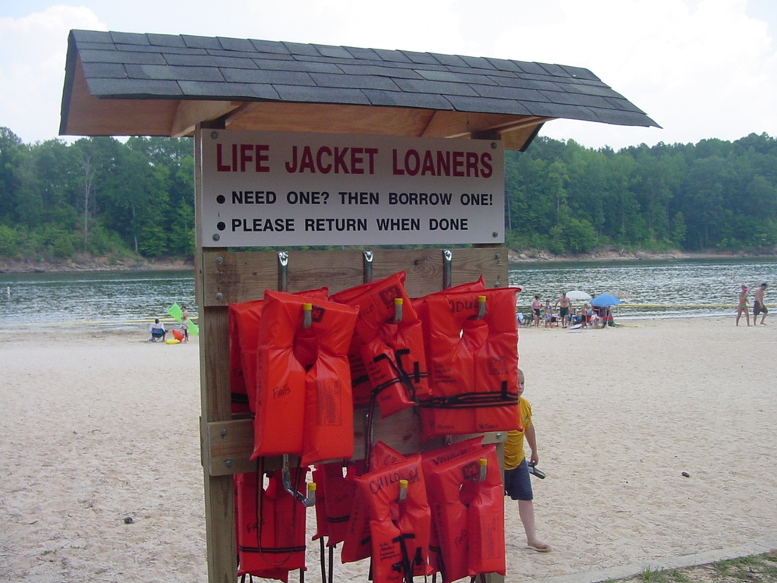
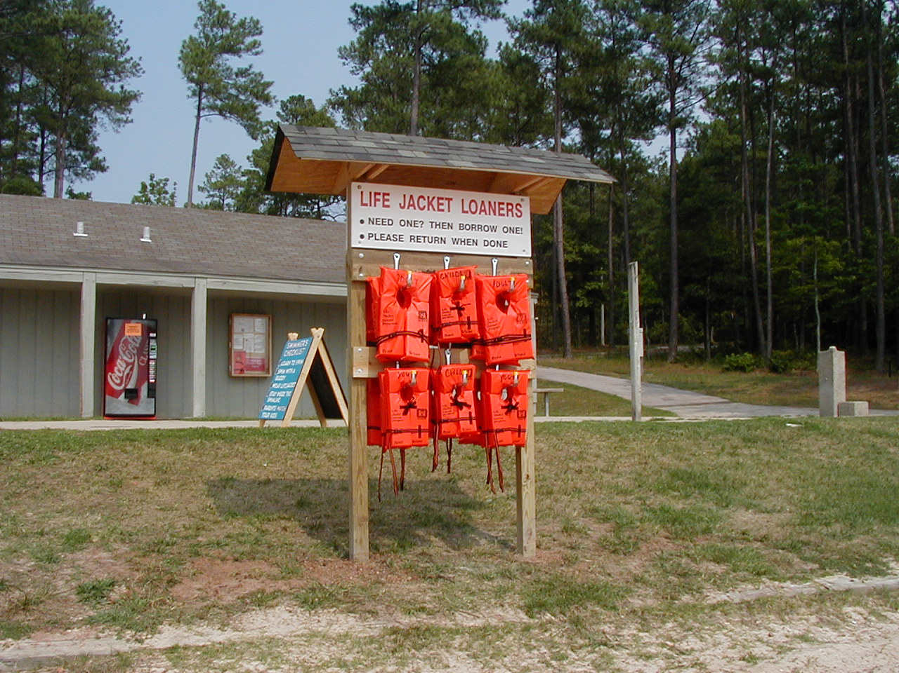
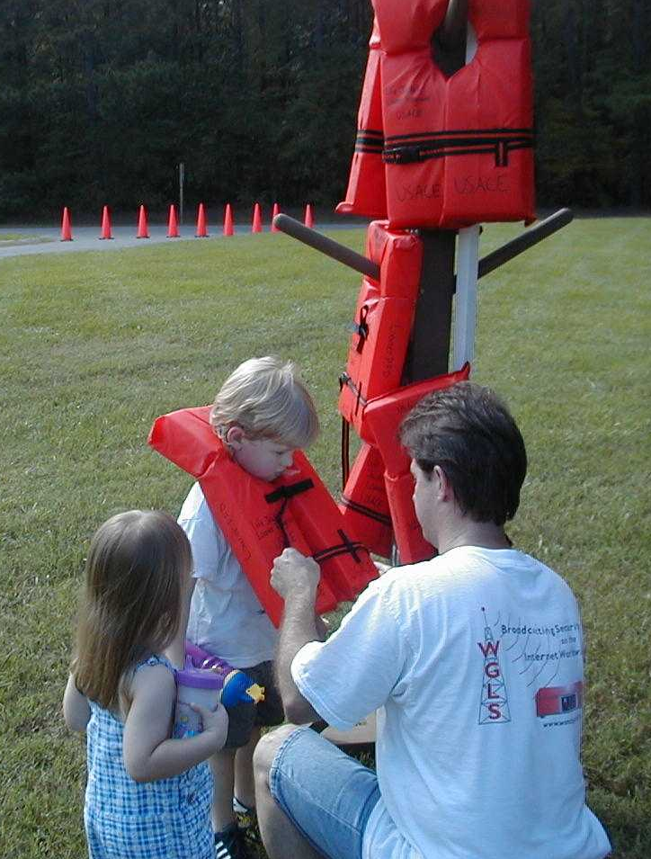
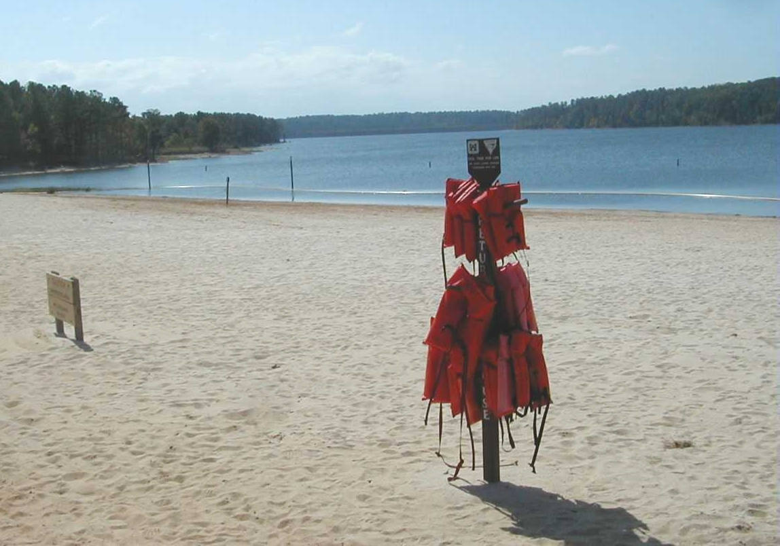

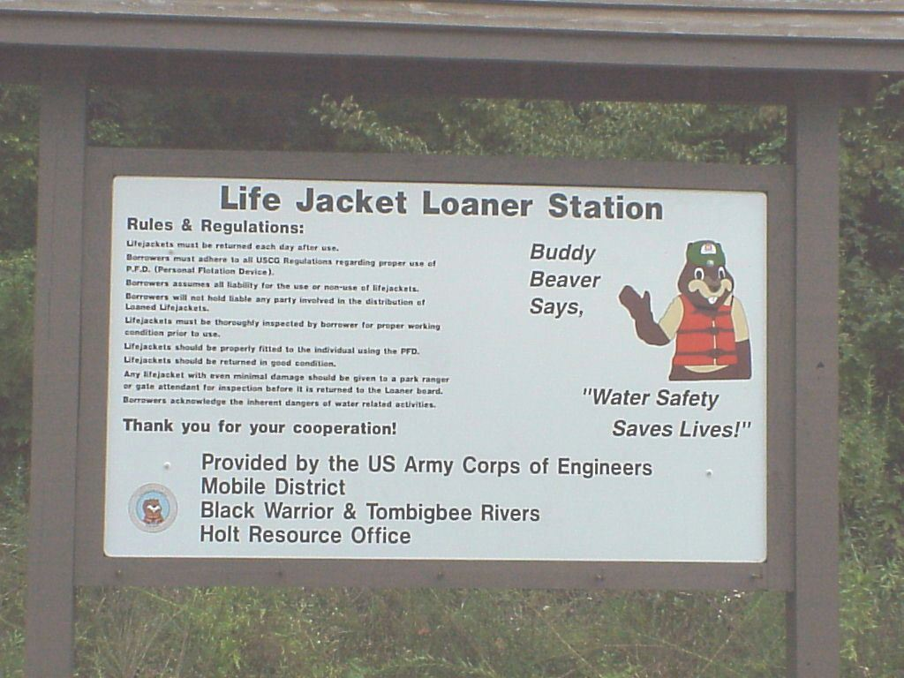
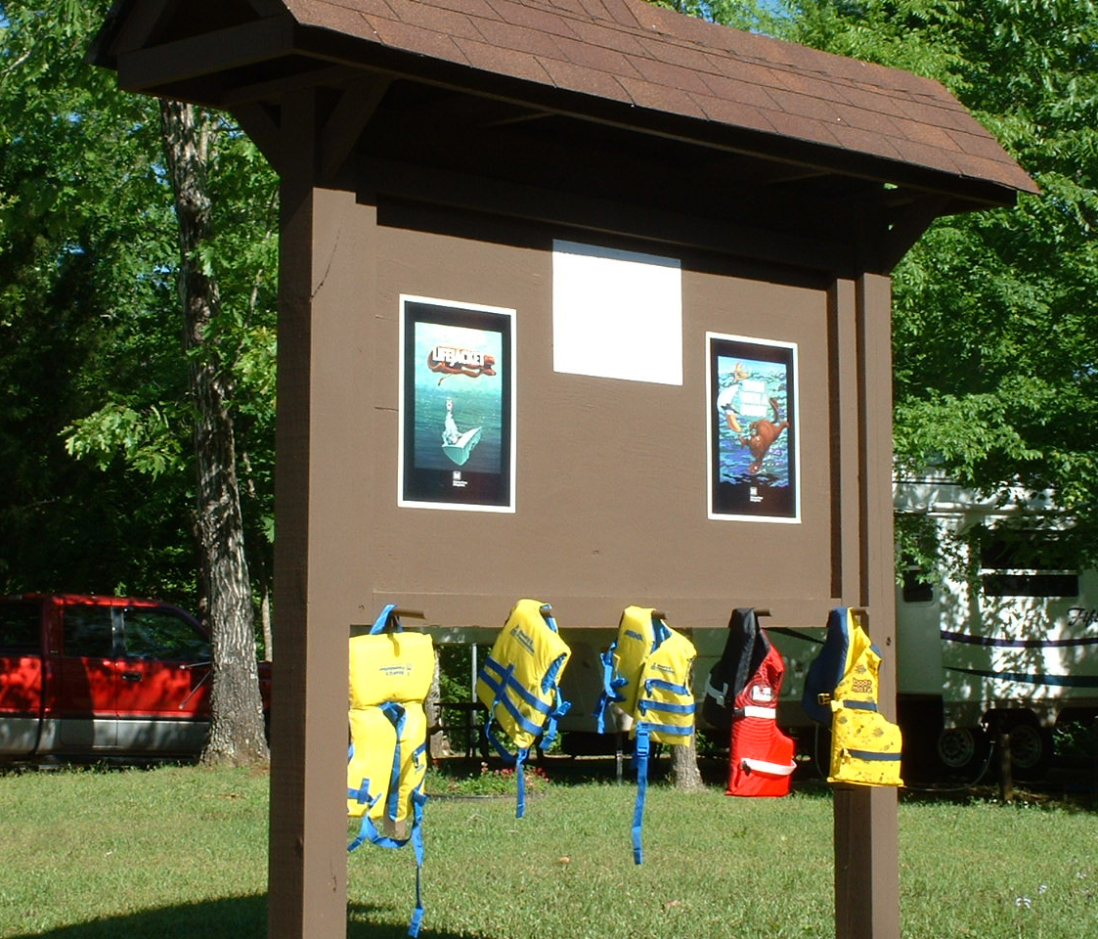

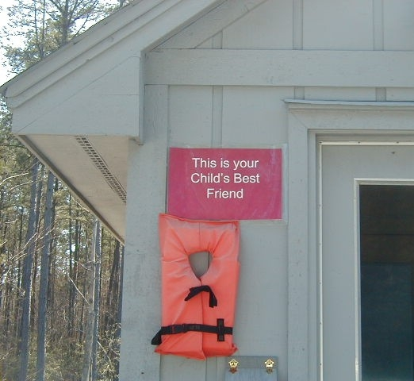
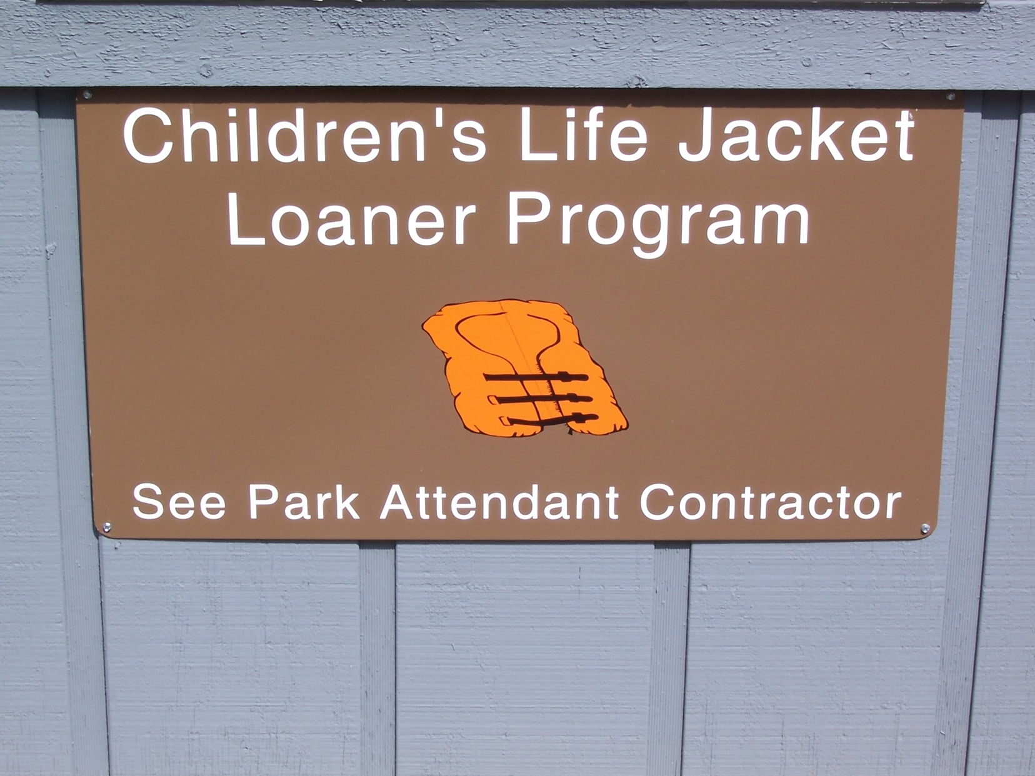
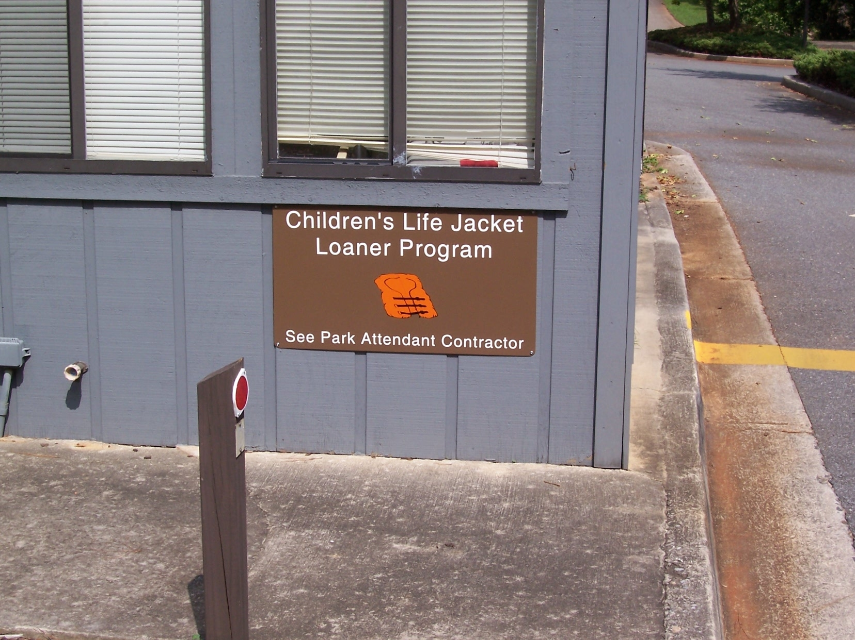
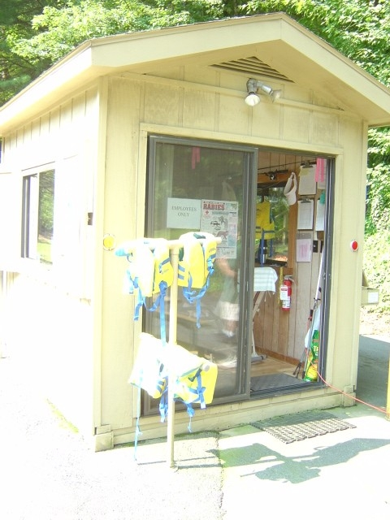
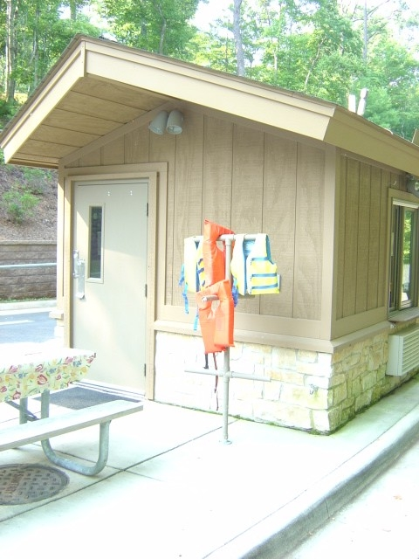
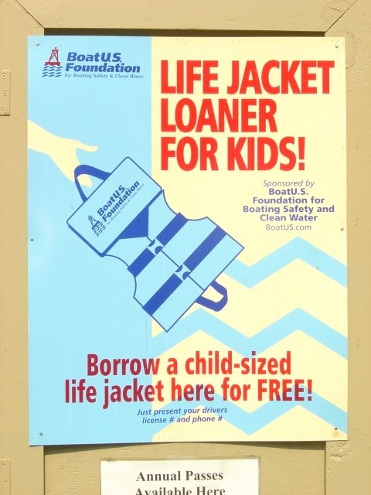
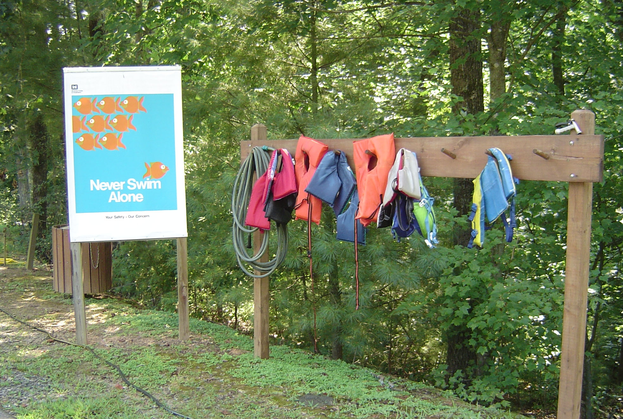
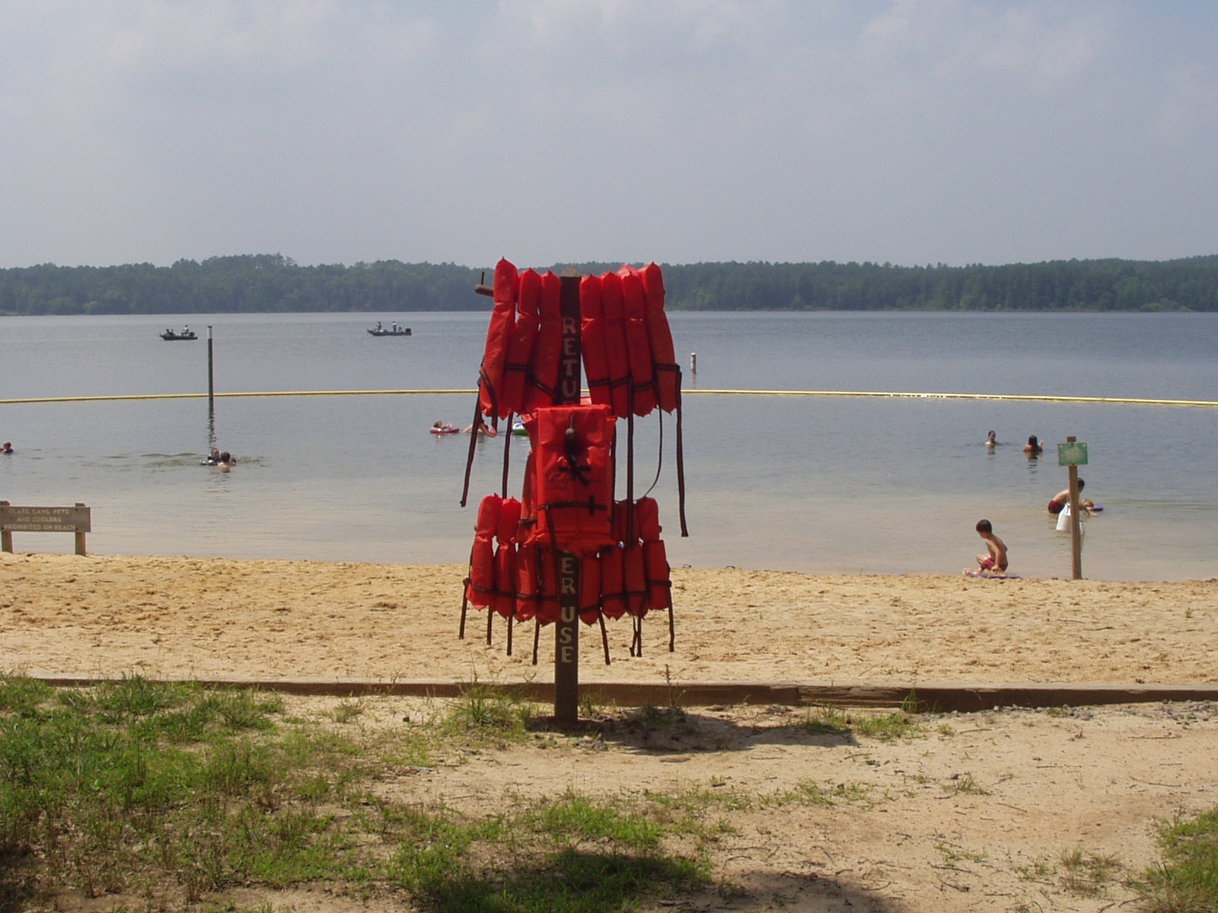
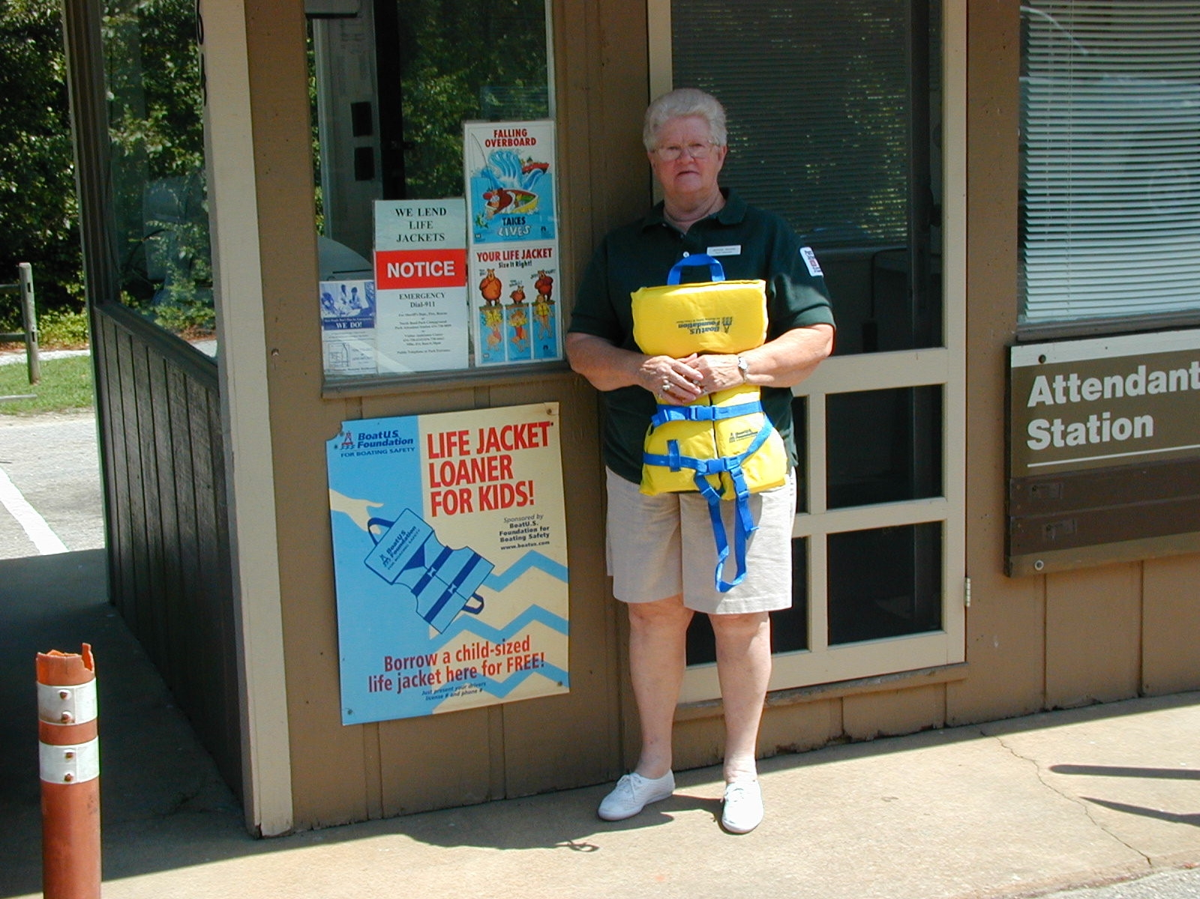
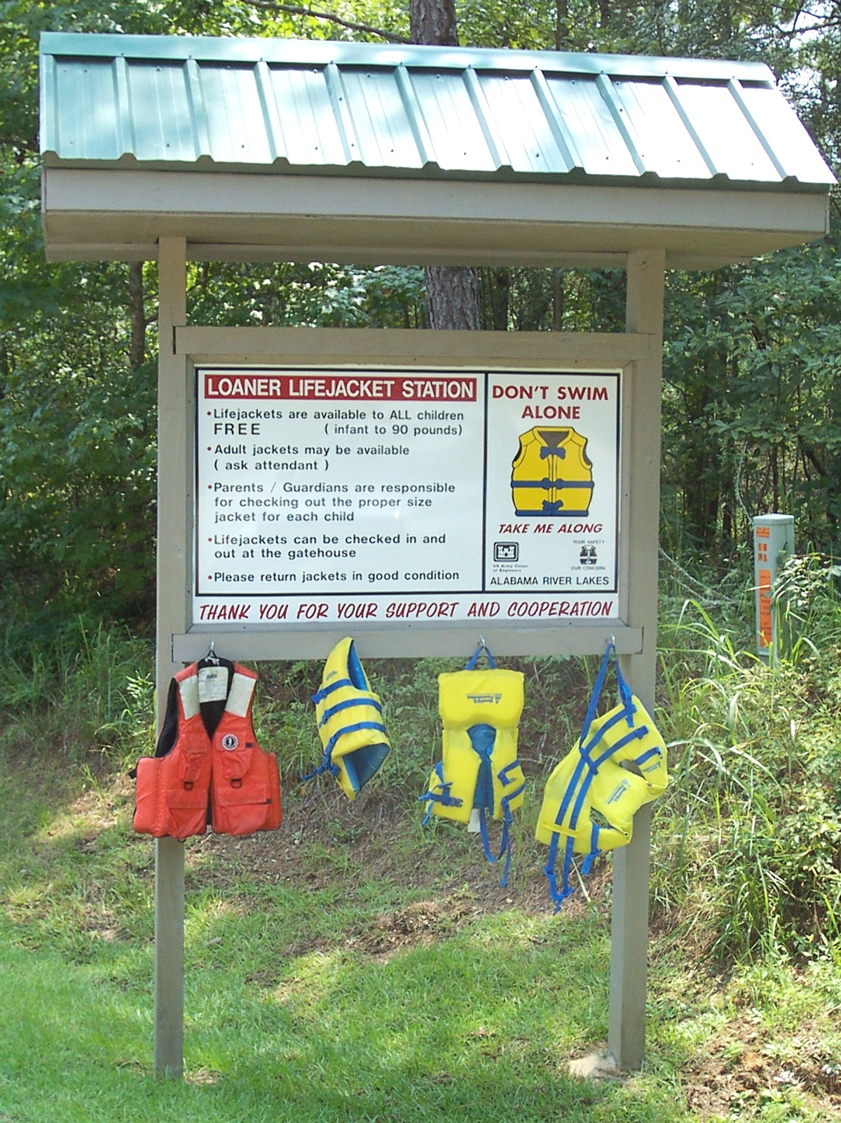

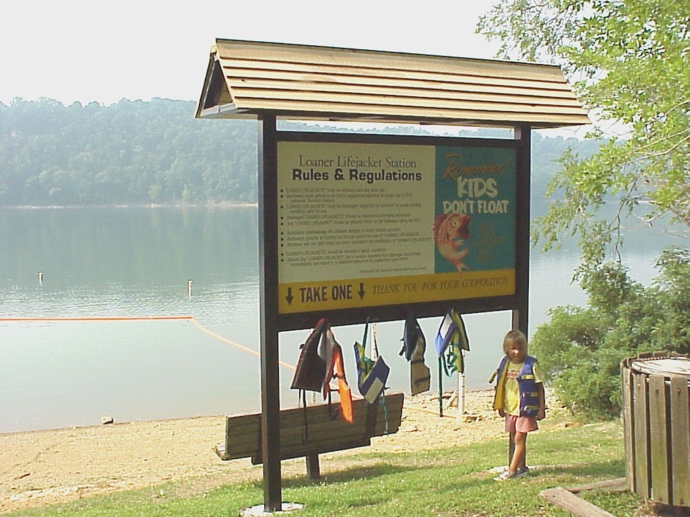
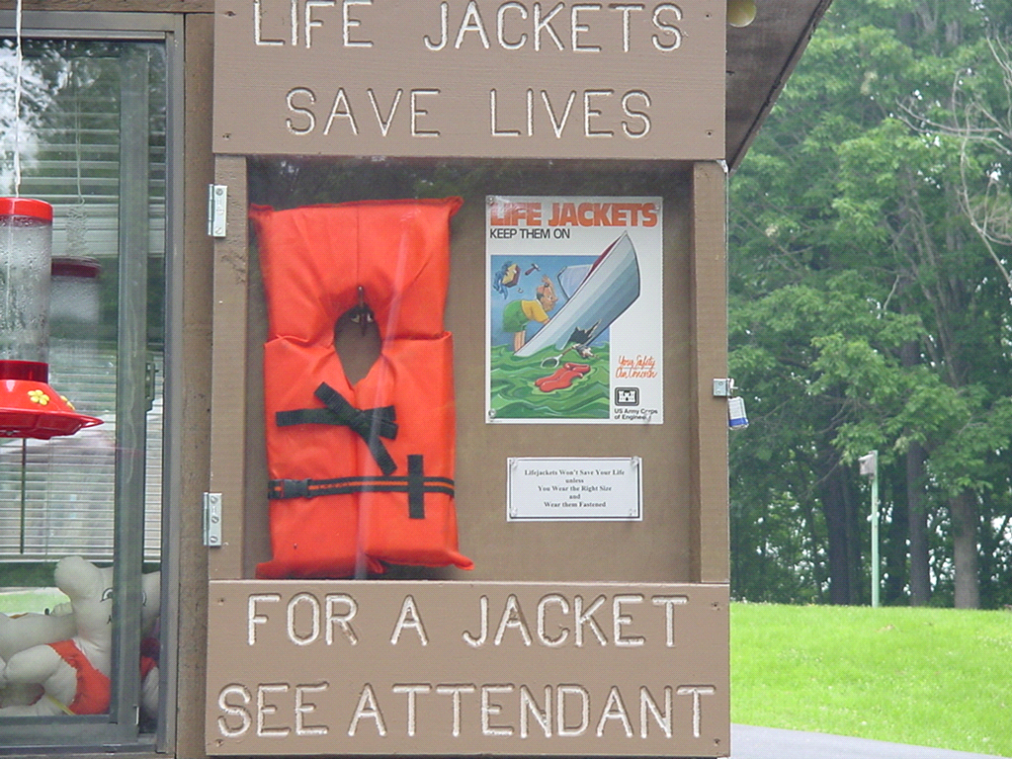

Appendix B

Sample Life Jacket Loaner Sign-Out and Liability Form

Life Jacket Loaner Program Form

Date Issued_______________________

Signature of Park Attendant: _______________________________________

Name of Guardian or Responsible Adult: ____________________________________

Mailing Address: _____________________________________________________
_____________________________________________________

Phone numbers- Work: ______________________ Home : _____________________

Cell: __________________________________________________________________

Driver License Number and State:___________________________________________

Vehicle Tag Number and State: ____________________________________________

Due Date and Time:_____________________ Date and Time Returned:___________

Activity to be used: (Circle one) Swimming Boating

Number of Life Jackets loaned:_____________ Size of Life Jackets:______________

By signing this document, you, the borrower, certify that you have inspected all life jackets being borrowed for appropriate fit and function. You, the borrower, agree to indemnify and hold harmless the park attendant and the U.S. Army Corps of Engineers against all claims, losses, damages, and any and all liabilities associated with this agreement and the loan of all life jackets as provided to you. The park attendant, in conjunction with the U.S. Army Corps of Engineers, offers this program as a free public service using Coast Guard approved equipment. As neither the park attendant nor the U.S. Army Corps of Engineers has any control over actual usage, neither the park attendant nor the U.S. Army Corps of Engineers assumes any liability for the use or misuse of the life jackets. Personal information recorded on this form will only be used for purposes consistent with the reason provided. Your personal information will not be shared with other parties unless we have asked for and obtained your explicit consent.

Signature of Guardian or Responsible Adult:

___________________________________

Formulario de Préstamo de Chalecos Salvavidas

Fecha _______________________

Firma del asistente del parque: _______________________________________

Nombre del adulto responsable: ________________________________________

Dirección: _________________________________________________________
_______________________________________________________

Teléfono del trabajo: ________________________ Casa: ____________________

Celular: ____________________________________________________________

Número y estado de la licencia de conductor:______________________________

Número y estado de la placa del vehículo: ________________________________

Fecha y hora de vencimiento: ______________ Fecha y hora de entrega:___________

Actividad para la cual se utilizará: (circule uno) Paseo en bote Nadar

Número de chalecos salvavidas prestados: _____________
Tamaño de los chalecos salvavidas:______________

Al firmar éste documento, usted, el prestatario, certifica que usted ha examinado todos los chalecos salvavidas que serán pedido prestados en cuanto a tamaño y función. Usted, el prestatario, acuerda indemnizar y liberar de toda culpa al asistente del parque y el U.S. Army Corps of Engineers de cualquiera responsabilidad, pérdida y daños asociados con éste acuerdo y el préstamo de los chalecos salvavidas. El asistente del parque y el U.S. Army Corps of Engineers ofrecen el uso de este programa gratuito al público, utilizando equipo aprobado por el U.S. Coast Guard. Como ni el asistente del parque ni el U.S. Army Corps of Engineers tienen control sobre el uso actual de los chalecos salvavidas, ninguno de los dos se hacen responsables por el uso indebido de los mismos. La información personal registrada en esta forma será utilizada solamente para los propósitos constantes con la razón proporcionada. Su información personal no ser compartida con otros partidos.

Firma del adulto responsable:

___________________________________
Appendix C
Sample Letter to Borrowers for Unreturned Life Jackets

The following is a sample letter to send to remind borrowers to return life jackets. It is at the discretion of the Operations Project Manager to determine the level of enforcement to be used for this program.
- - - - - - - - - - - - - - - - - - - - - - - - - - - - - - - - - - - - - - - - - - - - - - - - - - - - - - - - - - - - - -

Dear (borrower):

Our records show that you borrowed (insert number) life jacket(s) on (date) and forgot to return (it/them). Please return the jacket to (project site) as soon as possible. The life jacket loaner program depends on life jackets being returned for others to use.

Thank you for your cooperation with this matter. Please contact (name and phone number) if you have any questions regarding this matter.

Sincerely,
(name of person in charge of program)
(Title)
(Project name)
(XXX District)
U.S. Army Corps of Engineers

Appendix D

Sample Inspection Log

Life Jacket Loaner Station Restocking Report
Each station will be stocked with 4 Adult, 4 Youth, and 4 Child Life Vests. Each vest is to be inspected for wear and replaced if necessary. All clips should be fastened to assure they are in proper working order. Children's vests should be on the lowest level, youth vests on the middle level, and adults on the highest level. Duty Ranger will inspect loaner life jackets and file this report each Friday morning.
Complete and send summary report to Carmen Boyette
Ranger: Hosey |  |  |  | Date:
 |  | Replaced | Replaced | Replaced |  | Missing | Damaged
Location |  | Adult | Youth | Child |  | (ex: 2A, 1Y) | (ex: 1Y, 2C)
Ebenezer |  |  |  |  |  |  | 1A
Seaforth |  |  |  |  |  |  | 1Y
Parkers Creek |  |  |  |  |  | 1A, 1Y | 1A
 | Totals |  |  |  | Week'sTotals: | 1A 1Y | 2A, 1Y
 |  |  |  |  | Past Totals: | 1A, 1C
 |  |  |  |  | Updated Total | 2A, 1Y, 1C | 2A, 1Y
 |  |  |  |  | Loss to Date (Missing+Damaged) |  | 7
Notes:

Sample Life Jacket Inspection Form

(Inspection must be done at least weekly to determine life jackets’ serviceable condition)

Life Jacket # | 1. Is the life jacket free of tears or holes? | 2. Are buckles attached and working? | 3. Does zipper work properly? | 4. Is the USCG approved label attached? | 5. Are the buckle straps attached properly?
105 | YES | YES | NO | YES | YES
57 | YES | YES | YES | YES | YES

Comments and Codes:
CODES: S = Serviceable U = Unserviceable R= Removed from inventory

Life jacket # | Comment and code | Corrective action | Date Removed from Service
105 | U&R zipper tab missing | Need to order new tab. | 10 Aug 05
57 | S

Directions:

1. Write the life jacket number in the first column, then answer each question in the corresponding row using the following responses: YES, NO, or N/A

2. In the comment and codes section, describe the problem or hazard that is present, the corrective action, and then remove the life jacket from the recreation area.

Reviewed by: _________________________ Date: ________________________

Appendix E

Potential Partnership Opportunities

PFD Donations/Discounts/Grants:  Local water safety councils  Wal*Mart  Target  West Marine  Stearns  Walsh Marine  Dicks Sporting Goods  Sports Authority  Local sporting goods/outdoor stores  Boat U.S. Foundation  National Safe Boating Council  National Marine Manufacturers Assoc.  Yamaha  Kawasaki  Mercury Motors  Ranger Boats  Zodiac  Rotary  Lions Club  Ruritan  Civitan  Kiwanis  Shriners  YMCA  American Red Cross  American Legion  Religious organizations | Loaner Tree Material Donations/Discounts:  Home Depot  Lowe’s Home Improvement Warehouse  Ace Hardware  True Value Hardware  Local hardware stores  Wal*Mart  Target  Other Partners  US Coast Guard  US Power Squadrons  National Water Safety Congress

Appendix F

Sample Life Jacket Loaner Station
Design Plans and Costs
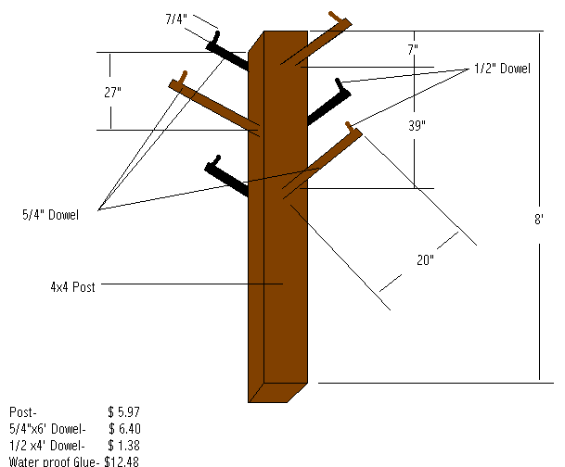
SAW- Jordan Lake Tree of Life
Startup cost for a tree - $26.23 plus costs for a gallon of paint and sign for the tree if desired. Some materials like the waterproof glue and paint can be used on multiple trees.

Trees are stocked with 22 Type II jackets (8 small child, 8 youth, and 6 adults). West Marine sells the PFDs to the Corps at a discounted price of $4.00 each. Total price to stock each tree with jackets is $88.00.

The project is currently working on a new sign for the trees with instructions and visuals about how to properly put jackets on. Estimated price = $50 per sign.

Annual Costs -
5-6 boxes of each size jacket: $720 to $864

SAM- Black Warrior & Tombigbee Rivers-
Sign produced by UNICOR- $1200

Appendix G

Life Jacket Loaner Program Communications Plan

1. Purpose: This appendix provides a communication strategy for project offices to use to launch a personal floatation device (PFD/life jacket) loaner program campaign. The PFD loaner program will provide a limited number of life jackets for the public to use for free while visiting South Atlantic Division (SAD) recreation areas. The PFD loaner program goals are to increase visitor awareness for the need to wear the appropriate size and type of life jacket while swimming and boating, and to encourage them to enjoy a safer recreational experience.

2. Applicability:
- Applies to all SAD river and lake projects.
- Applies to all SAD public affairs offices that support the river and lake projects.

3. Background: In fiscal year 2004, SAD saw an increase in boating and swimming fatalities. Research shows that approximately 90 percent of drownings at Corps projects could have been prevented if a personal floatation device had been worn. The SAD product delivery team (PDT) recommended implementing a Division-wide life jacket loaner program. The target implementation date is 20 March 2006.

4. Execution and Planning.
- Primary message: Most water-related deaths can be prevented.
- Theme: Play smart, leave alive!
- Emphasis Points:
Always wear a life jacket
Learn to swim
Boat Safe, Boat Sober

5. Implementation. The communications plan is comprised of generic items that can be tailored for specific audiences. Each project will determine the target audiences and the appropriate material to use for that group.
- Talking points for media and general public (Appendix H)
- Press release for media (Appendix I)
- Bilingual posters (Appendix J)
- Bilingual handouts (Appendix K)

Appendix H
Life Jacket Loaner Program Talking Points

Life Jacket Loaner Stations
- Each year, approximately 150 people die in Corps lakes and rivers nationwide. We want to increase public awareness of the need for water safety and to provide safety equipment for their use
- Life jacket loaner stations will be set up to provide life jackets to swimmers at each designated swim area in U.S. Army Corps of Engineers recreation areas. Stations may also be set up near Corps launch ramps for boaters.
- Life jacket loaner stations may be located at gate houses, visitor centers, swim beaches, marina offices, fuel docks, boat ramps, or similar facilities. The loaner station design and program execution may vary at each Corps recreation area.
- Promotional posters will be posted at gate houses, launch ramps, visitor centers, restrooms, swim beaches, or similar facilities to increase visitor awareness about the program and to encourage water safety practices.

Life Jackets save lives
- The best way to prevent a water fatality is to Wear A Life Jacket anytime you are in, near or on the water, whether it is playing on the beach or at a boat ramp.
- Many people who drown never intended to enter the water, and a substantial number knew how to swim.
- According to U.S. Coast Guard 86 percent of the 2003 drownings could have been prevented if the people wore life jackets -- 416 people would have survived.
- We have a limited free life jacket loaner program for our visitors. Ask a ranger or gate attendant for specific information about how the program works or to borrow a life jacket.

Water fatalities
- Water fatalities do not discriminate based on gender, age or race.
- Annually, approximately 160 people die in Corps rivers and lakes nationwide.
- Water fatalities at the Corps projects happened when:
Swimming | Wading
Boating | Fishing from boat or pier
Launching a boat | Hunting from boat
Riding Personal Water Craft | Person struck by lightning
Carbon monoxide poisoning

2005 Fatality Numbers by Project
SAM |  | SAS
1 | West Point | 1 | Russell
3 | Alabama River Lakes | 2 | Thurmond
1 | Seminole | SAW
2 | Lake Lanier | 1 | Jordan
5 | Allatoona | SAJ
3 | Tenn-Tom | 2 | Lake Okeechobee & OWW
3 | Black Warrior

- Most people who end up in the water, never intended to be in the water.
- Putting on a life jacket when you need it is as likely as putting on a seat belt right before a crash – once you need it, it is too late.
- You can drown in less than one minute.
- Don’t over estimate your swimming skills.

Stay Alive Messages
- Always wear a life jacket. (Siempre use un chaleco salvavidas.)
  - Children should wear life jackets when playing in or near the water. (Niños deben usar chalecos salvavidas al jugar adentro o cerca del agua.)
  - Everyone should wear life jackets from the time they arrive at the boat ramps until they tow boat out of the water. (Cada uno debe usar chalecos salvavidas a partir del tiempo momento que llegan a las rampas de botes hasta que remolquen el bote fuera del agua.)
  - If you don’t have a life jacket, talk to a ranger or park attendant about our loaner program. (Si usted no tiene un chaleco salvavidas, hable con un guarda parques o un asistente del parque sobre nuestro programa al prestamista.)
- Always swim with a buddy. (Nada siempre con un amigo.)
- Learn how to swim. (Aprende a nadar.)
- Never dive into unknown waters. (Nunca se zambulla en las aguas desconocidas.)
- Take a Boating Safety Course. (Tome un curso sobre la seguridad del paseo en bote.)
- Parents, always watch your children! (¡Padres, vigilen siempre a sus niños!)

Appendix I
Sample Press Release

XXXXXX Lake launches life jacket loaner program

(Add article here)

Graphic – Photo of Life Jacket loaner station at project
Sidebars --
1. Boat Safe
Safe boating isn’t just the responsibility of the person behind the wheel; it applies to everyone on board. Most boaters do not plan on falling overboard, and when they do, it is too late. Putting on a life jacket when you need it is like trying to put on a seat belt just before a crash.

According to 2003 U.S. Coast Guard statistics, there were 703 boating fatalities in U.S. waters; 576 did not wear life jackets. In the same year, 481 people drowned; 416, almost 86 percent were not wearing life jackets. Many had basic swimming skills, yet that was not enough to save their lives.

The following rules of the water apply to personal watercraft users as well as boaters.
- Always wear a life jacket in, near and on the water. (Utiliza siempre un chaleco salvavidas aprobados por el U.S. Coast Guard cuando, dentro, y cerca del agua.)
- Boat safe, boat smart, boat sober. (Navegar seguro, navegar sabiamente, navegar sobrio.)
- Be weather wise; watch for summer storms. (Conozca el estado del tiempo; vigile por las tormentas del verano.)
- Have the required safety equipment on board. (Ask a ranger if you are not sure what equipment you are required to have.) (Tenga todo el equipo requerido de seguridad a bordo. Pregunte al guarda parques si usted no está seguro de qué equipo requerido.)
- Know how to swim. However, if your swimming skills fail you, a life jacket may save your life. (Sepa nadar. Sin embargo, si sus habilidades para nadar le fallan, a el chaleco salvavidas puede salvarle la vida.)
- Be aware of floating and submerged objects. (Esté enterado de los objetos flotantes y/o sumergidos.)
- Take a boating safety course. (Tome un curso sobre la seguridad del paseo en bote.)
- Remember it’s not just the other guys -- fatalities include people just like you! (Recuerde qué no es solamente los otros individuos -- ¡Las fatalidades incluyen a la gente como usted!)

2. Swim Safe
- Always wear a life jacket. (Siempre use un chaleco salvavidas.)
- Always swim with a buddy. (Siempre nada con un amigo.)
- Always swim in designated areas. (Siempre nade en áreas designadas.)
- Know what is underwater before you jump. (Sepa lo que esta sumergido antes de saltar.)
- Learn how to swim. (Aprende a nadar.)
- Always be weather wise, watch for summer storms. (Conozca el estado del tiempo, vigile por las tormentas del verano.)
- Always watch your children! (¡Vigile siempre a sus niños!)

Appendix J

Sample Posters

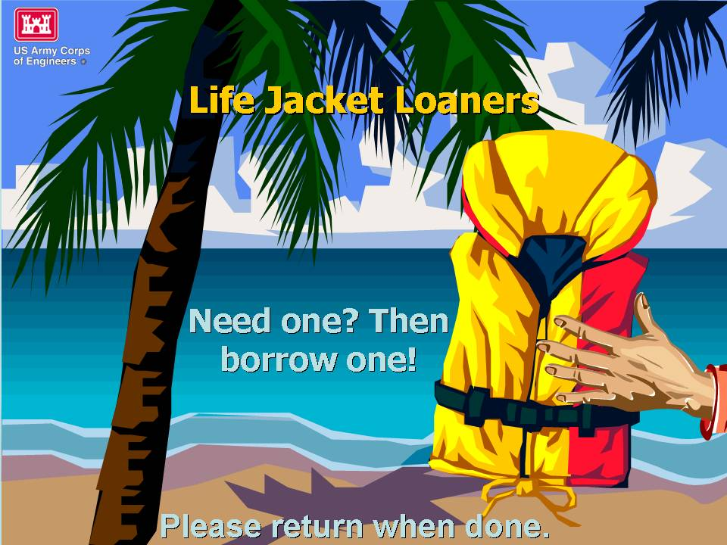
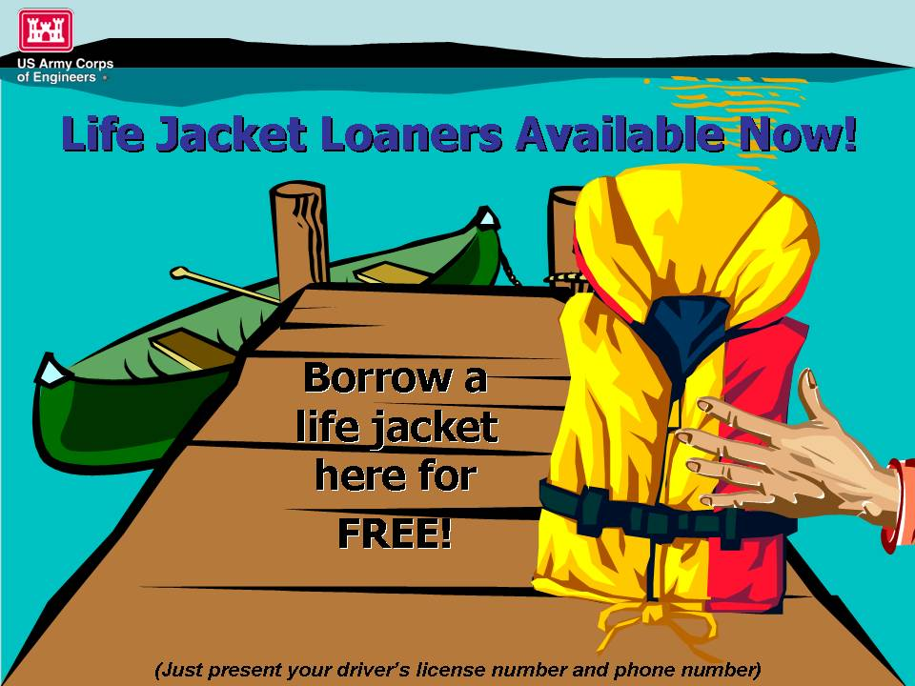
Posters at Gate House
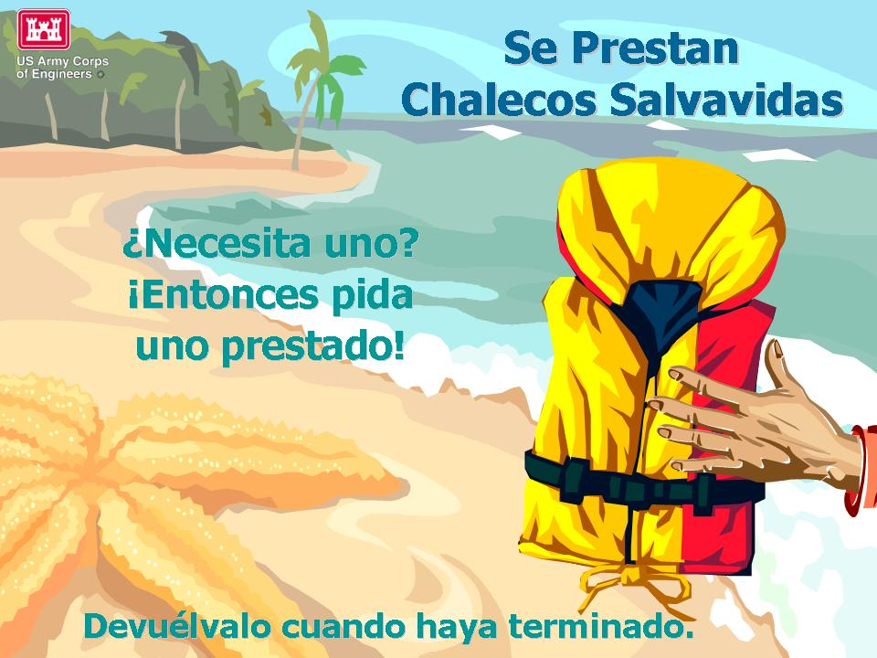
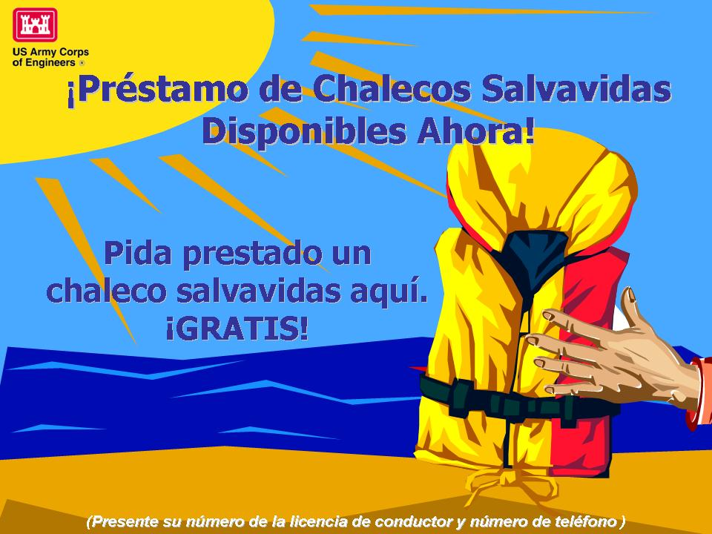
Posters at Loaner Kiosk
Posters at Gate House

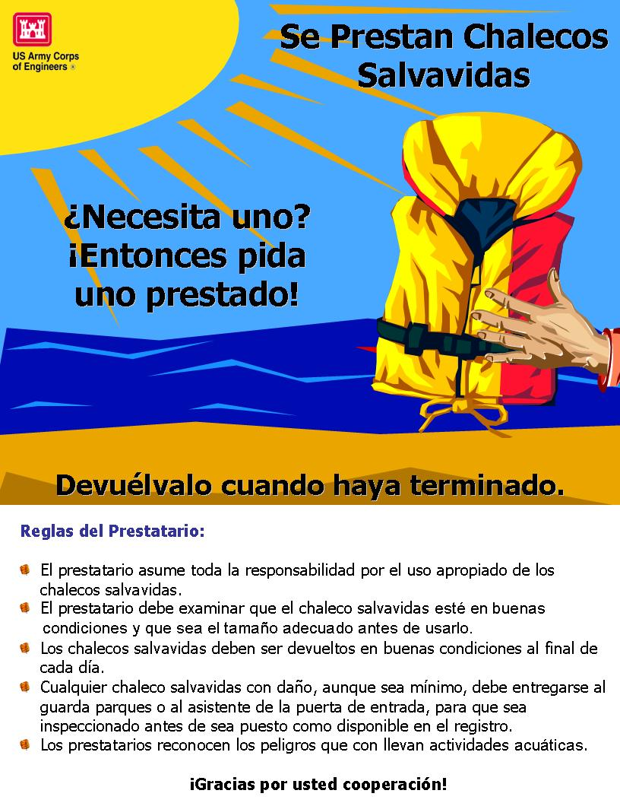
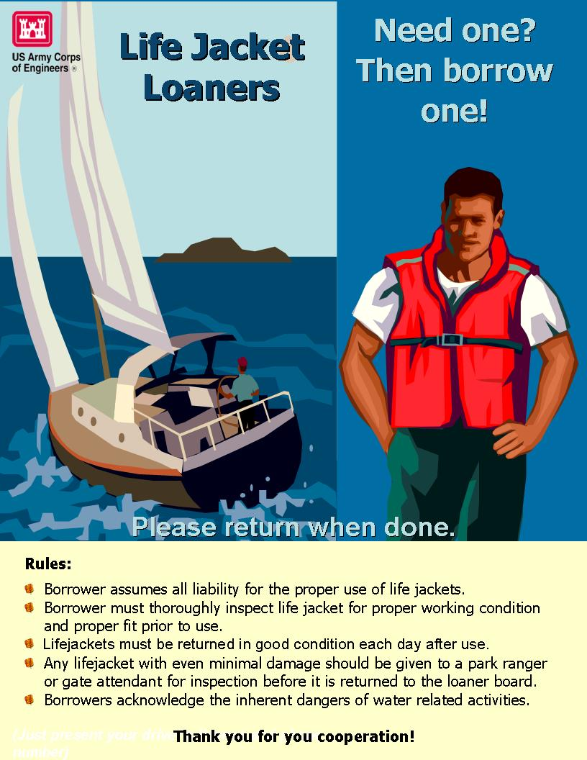
Appendix K

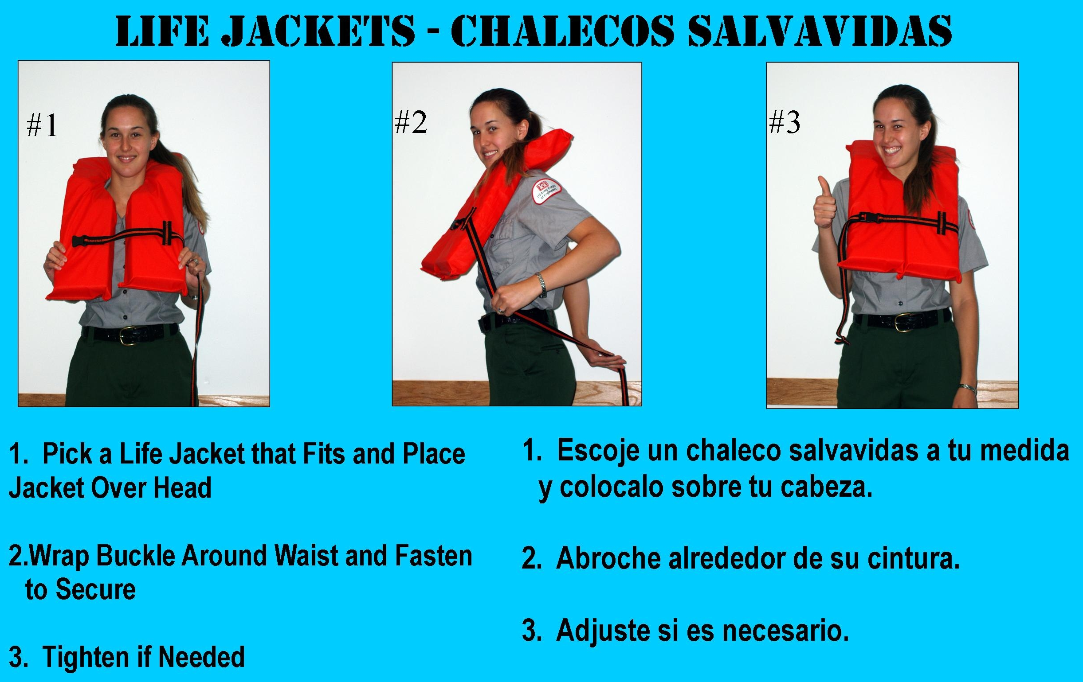
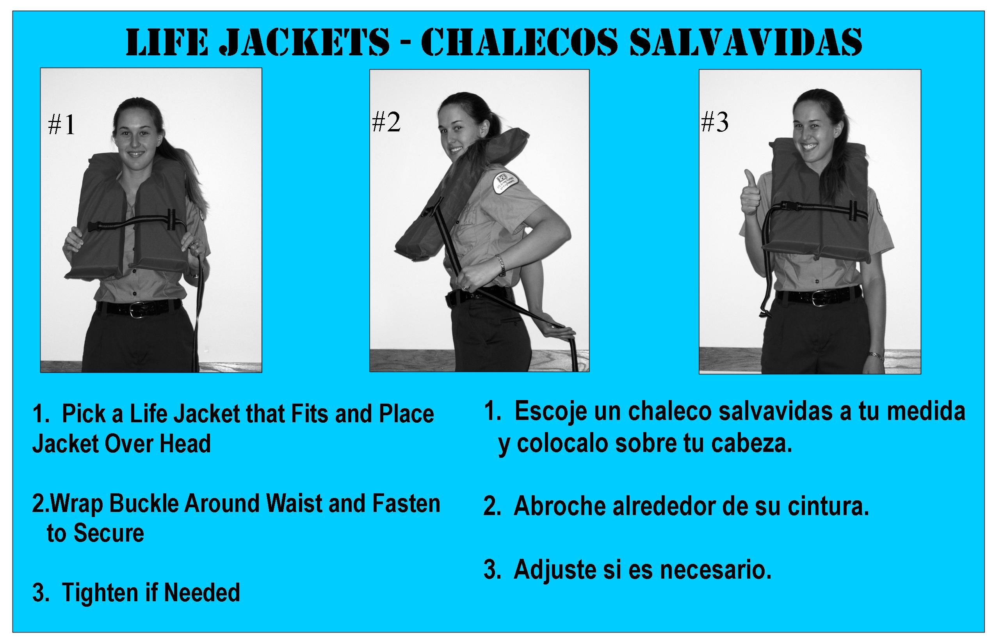

Sample Handouts/Flyers



